**AI3021-IT IN AGRICULTURE**

**CLIMATE VARIABILITY, SEASONAL FORECATING AND THEIR IMPACT ON INDIAN ECONOMY**

**ASSIGNMEENT - 2**

**Submitted By:**

**Name: Anisha A**

**Reg No: 950021104005**

**Dept: B.E- CSE**

**Year: IV**

**CLIMATE VARIABILITY:**

Weather can be highly variable on a daily, weekly, or even yearly basis – one day it might be sunny and the next it’s snowing.**Climate** on the other hand, doesn’t change day-to-day because it is based on longer time scales and averages. However, climate is variable as well.

***[1]Climate variability is the way aspects of climate (such as temperature and precipitation) differ from an average. Climate variability occurs due to natural and sometimes periodic changes in the circulation of the air and ocean, volcanic eruptions, and other factors.***

For example, the average daily maximum temperature in July, averaged over 30 years from 1988 through 2017, in Boulder, Colorado was 87.7° F (30.9° C). However, in some years, the month of July has been warmer than the average. In other years, the month of July is cooler than the average.

Worldwide, the average global temperature is rarely exactly the same from year to year. One year might be cooler than the year before, even though the long-term trend shows increasing temperature over time due to climate change. There are many reasons for climate variability, including natural fluctuations like the ENSO (El Nino Southern Oscillation). Scientists are currently researching the impact that climate change has on variability.

Extreme events are specific weather events that depart from the average in some significant. For example, days that exceed 100° F (37.8° C) are called extreme heat events in many locations. While it's possible that any given summer day might be over 100° F, climate warming is causing the frequency of extreme heat days to increase. In other words, the probability of a summer day with extreme heat is becoming higher as climate warms.

Climatologists are concerned with more than temperature changes as climate changes. Extreme precipitation events are also important. Precipitation patterns that deviate significantly from the average can result in droughts or floods. The flooding in Texas in August 2017 caused by Hurricane Harvey is a recent and devastating example of an extreme precipitation event.

**[2]HISTORICAL CLIMATE PATTERNS OF INDIA:**

India’s land surface can be divided into six physiographic regions:

* Himalayan mountains in the north,
* Peninsular Deccan Plateau,
* the Indo-Gangetic Plains,
* Thar Desert in the west,
* Coastal Plain, and
* the Islands.

All these regions have different climate profile and vulnerabilities. The country’s is influenced by the presence of the Himalayas in the northern part of the country and the Thar Desert in the west.

The Himalayan Mountains act as a barrier to winds from Central Asia and China, enabling India’s climate to be warmer than other countries at similar latitudes.

The northern part of the country is characterized as a continental climate with hot summers and cold winters.

The coastal regions of the country, however, experience warmer temperatures with little variation throughout the year and frequent rainfall.

**India’s seasonal cycle for the latest climatology** (1991-2020):

India’s **monsoon season** runs approximately from **June to October**, arriving later in more northerly regions and delivering over 80% of the territory’s annual precipitation.

A **shorter rainy season** occurs during the months **of October through December** following the summer monsoon and is referred to as the post monsoon season.

The **southwest monsoon season (June-September)** generates average monthly rainfall between 150 millimeters (mm) to 270 mm. **The northeast monsoon season (October-December)** generates average monthly rainfall between 10 mm and 75 mm.

Large inter-annual variability is a key feature of the rainfall regime of India. This is due to both remote and *regional climate influences* of the **El Niño Southern Oscillation (ENSO) and Indian Ocean Dipole on the monsoon**.

**Summer (May-September)** temperatures are consistently high across India’s territory, with some small exceptions in its most mountainous regions.

**Winter (November-March)** temperatures are more variable, and this variation along with different precipitation patterns determines the many climatic zones of India. The winter season brings dry and clear weather with low humidity and temperature during the months of January and February.

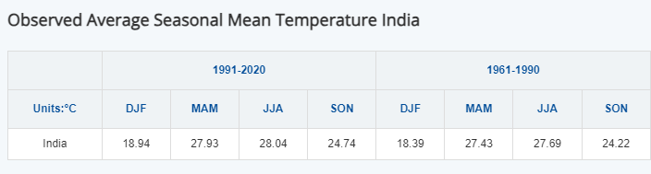

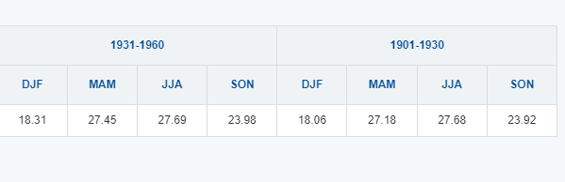

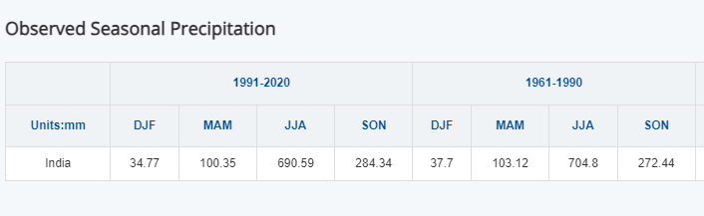

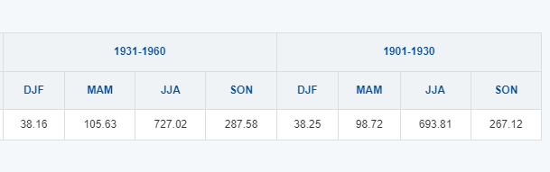

**Insights from the data:**

* Agricultural Impact: Increasing temperatures and changes in precipitation patterns can significantly affect crop yields and agricultural practices, which are crucial for food security in India.
* DJF: There’s a noticeable increase in the mean temperature from 1901-1930 to 1991-2020.
* MAM and JJA: The increase is evident, suggesting warming trends in pre-monsoon and monsoon seasons.
* SON: The temperatures have also increased, indicating changes in the seasonal climate pattern.
* JJA (Monsoon Season): The data indicates high average precipitation, but there are variations over decades, suggesting shifts in monsoon intensity and distribution.
* DJF and SON**:** Lower precipitation during winter and post-monsoon seasons shows some variability, which could affect water resources.

**CLIMATE VARIABILITY AND ITS EFFECT ON INDIAN ECONOMY:**

India’s economy is [one of the most nature-dependent in the world](https://www3.weforum.org/docs/WEF_New_Nature_Economy_Report_2020.pdf). Some 33% of its GDP is generated in sectors classed as highly dependent on nature. These include forestry; agriculture; fisheries and aquaculture; food, beverages and tobacco; energy and water utilities and construction.

Many of these are threatened directly by the impacts of climate change, including rising sea levels, receding glaciers and unpredictable monsoon patterns. Agricultural output alone is predicted to drop by 16%, equivalent to a 2.8% GDP loss by 2030.

Yet, the same sectors are also the largest contributors to greenhouse gas emissions. The energy sector accounts for just below 70%, followed by agriculture, forestry and other land-use, which adds nearly 6%, the Forum’s white paper highlights.

It is estimated that India could account for about 3.4 crore of the projected eight crore global job losses from heat stress by 2030. The Reserve Bank of India’s latest [report](https://rbidocs.rbi.org.in/rdocs/Publications/PDFs/RCF03052023395FAF37181E40188BAD3AFA59BF3907.PDF) suggests that up to 4.5 per cent of India’s GDP could be at risk by 2030, owing to lost labour hours from extreme heat and humidity.

**[3]SECTORAL ECONOMIC EFFECTS OF CLIMATE CHANGE**

**Agriculture:** Climate change can severely disrupt crop cycles and can cause low agricultural yield. Agriculture, with its allied sectors, is the largest source of livelihood in India and contributes significantly to the economy. Low yields can hit the rural economy and push inflation in urban areas as well.

**Industry:** There could be an increase in operational costs and a reduction in profits in the industrial sector. The reasons for high costs can be the imposition of new climate-friendly regulations, reduced utilisation of old stock, and diversion of investment towards greener infrastructure. Relocation of production processes and activities due to climate-related losses can also add to the economic loss.

**Services:** Pressure on financial services, increased insurance claims, and disruptions in travel and hospitality can pose multiple threats to the service sector.

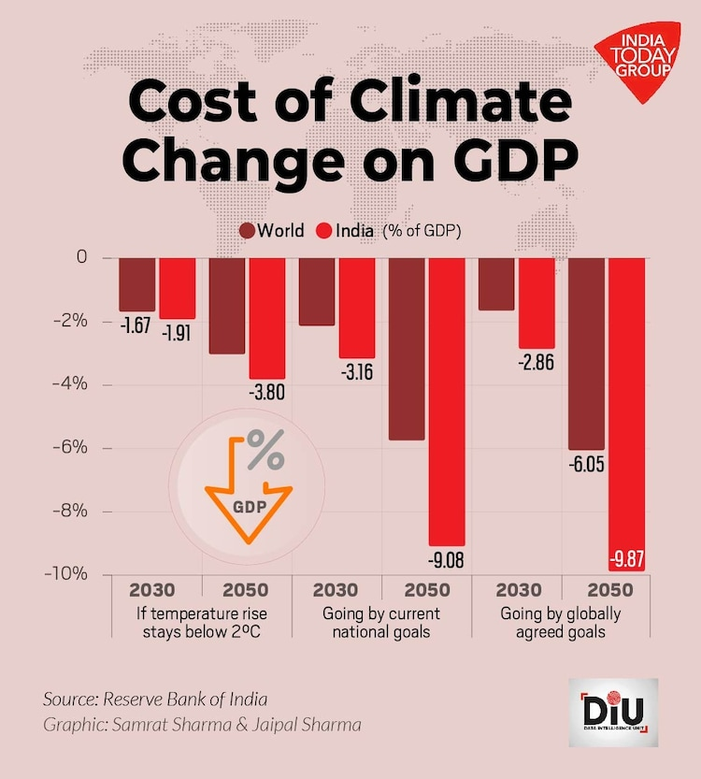

**Labour market:** Health hazards could lead to a loss in productivity and can also cause migration from areas that are more prone to climate risks. The RBI classifies risks from climate change into two categories: physical risk and transition risk. Physical risks include extreme weather events, shifts in temperature, precipitation patterns, etc. Transition risks, on the other hand, include credit, market, liquidity, operational, and reputational risks for banks and financial institutions, etc.

**Dual Role of Contributing Sectors:**

While agriculture and energy are heavily impacted by climate change, they also significantly contribute to greenhouse gas emissions. The energy sector is responsible for nearly 70% of emissions, while agriculture and forestry add another 6%, highlighting the need for both mitigation and adaptation measures in these sectors to reduce the long-term economic toll.

In conclusion, climate variability poses a substantial threat to India's economy, with the agricultural sector facing the most direct and immediate consequences. The long-term economic resilience of the country will depend on adopting sustainable practices across industries, reducing emissions, and mitigating risks related to both physical climate impacts and the transition to a greener economy.

**[4]Case Study: Flood and Drought in Chennai (2015-2017)**

**1. Introduction**

Chennai, the capital of Tamil Nadu, is one of India's largest and fastest-growing cities, located on the east coast facing the Bay of Bengal. This geographic position makes it vulnerable to tropical cyclones and extreme weather events. Between 2015 and 2017, the city faced contrasting climate challenges: devastating floods in late 2015 followed by severe drought conditions in 2016-2017. This case study explores the events surrounding these climatic extremes, their causes, and the implications for urban planning and water management.

**2. 2015 Floods**

Background In November and December 2015, Chennai experienced unprecedented rainfall during the northeast monsoon season, resulting in significant flooding. Historically, Chennai has relied heavily on this season for most of its annual rainfall. However, the 2015 rains led to catastrophic flooding that inundated low-lying areas, caused widespread damage, and necessitated large-scale rescue and evacuation efforts.

**2.1 Rainfall and Impact**

* The intensity of rainfall during this period was unprecedented, leading to the overflow of the Adyar River, which flooded several neighborhoods.
* Many areas that previously did not experience flooding were submerged, illustrating a failure to understand the city’s natural drainage systems.

**2.2 Causes of the Floods**

* Urban Planning Failures: The state government’s decision to drain excess water from reservoirs contributed to increased water flow in the Adyar River. This decision exacerbated flooding in newly affected affluent neighborhoods, revealing serious flaws in urban planning and infrastructure.
* Wetlands Degradation: A study by Care Earth Trust highlighted the impact of rapid urbanization on the city’s wetlands and waterbodies, which had been steadily reduced over the decades. The loss of these natural buffers increased the city’s vulnerability to flooding.
* Historical Context: Although Chennai had experienced previous floods, studies showed no significant increase in annual rainfall rates over the years. Instead, extreme flooding events were often linked to isolated but intense rainfall events and human activities.

**2.3 Societal and Economic Impact**

* The floods disrupted daily life, caused extensive property damage, and strained emergency services. The events prompted a re-evaluation of urban resilience and preparedness for extreme weather events.

**[5]3. Drought (2016-2017)**

**3.1 Water Scarcity:**

In stark contrast to the flooding in 2015, Chennai faced a severe drought in 2016 and 2017, marked by dangerously low water levels in the city’s reservoirs. By mid-2017, the reservoirs recorded only 1.3% of their total capacity, making it one of the worst droughts in the city's history.

**3.2 Reservoir Levels**

* Chembarambakkam Lake: 1 mcft (capacity: 3,645 mcft)
* Redhills Lake: 28 mcft (capacity: 3,300 mcft)
* Poondi Lake: 118 mcft (capacity: 3,231 mcft)
* Cholavaram Lake: 4 mcft (capacity: 1,081 mcft)

**3.3 Factors Contributing to Drought**

* Monsoon Failures: The city received only 390 mm of rainfall in 2018, significantly below the normal of 850 mm expected during the northeast monsoon. The failure of the monsoon directly impacted reservoir replenishment and water availability.
* Dependence on Reservoirs: The CMWSSB had to ration water supplies from January 2017, reducing the daily supply from 880 million liters to 550 million liters. By mid-May 2017, the agency stopped drawing water from Redhills Lake, further straining water availability

**3.4 Predictions and Recommendations**

Weather experts like Pradeep John indicated that the reservoirs could run dry by July 2017 without substantial rainfall. He emphasized the importance of rainwater harvesting and effective water management to mitigate future crises.

**4. Conclusion**

The contrasting climate events of floods and droughts in Chennai between 2015 and 2017 underscore the city’s vulnerability to climate variability and the need for sustainable urban planning. The flooding highlighted significant flaws in disaster preparedness and urban drainage systems, while the subsequent drought exposed the city’s over-reliance on limited water sources.

This case study emphasizes the importance of integrated water resource management and resilient urban planning to cope with extreme weather events in the future.

**SEASONAL FORECASTING:**

Seasonal forecasting refers to predicting weather patterns and climate conditions over a specific period, typically ranging from a month to several months in advance. This type of forecasting is crucial for various sectors, including agriculture, water resource management, disaster preparedness, and energy planning.

Seasonal climate forecasts are being increasingly used to benefit decision-making in the more climate-sensitive sectors of the economy. The second role of the chapter is to provide a broad research context for applications of seasonal forecasting to manage risk arising from climate variability. Farmers are the major group of potential users, and they have identified more confident use of forecasts as a priority for research.

Extensive but neglected research on how risky decisions are made is reviewed to look for opportunities for alternative ways of presenting probability information. The relatively recent impact of probabilistic thinking on human affairs suggests that the concepts are not intuitive.

Alternatives could take account of research on biases in intuitive approaches, and thus contribute to greater confidence in the use of seasonal forecasts. The communication aspects of seasonal climate forecasts warrant greater priority if the potential importance of the forecasts in improved risk management is to be realized.

Here’s an overview of seasonal forecasting, including its methods, applications, and importance:

**1. Purpose of Seasonal Forecasting**

* **Agricultural Planning**: Helps farmers make informed decisions about planting and harvesting times, crop selection, and resource allocation.
* **Water Management**: Aids in managing water resources by predicting rainfall patterns, which is crucial for reservoirs and irrigation systems.
* **Disaster Preparedness**: Enables authorities to prepare for potential extreme weather events, reducing risks to life and property.
* **Energy Management**: Assists energy companies in predicting demand fluctuations based on seasonal weather patterns.

**2. Methods of Seasonal Forecasting**

* **Statistical Methods**: These methods analyze historical weather data to identify patterns and relationships that can predict future conditions. Techniques include regression analysis, time series analysis, and analog methods.
* **Dynamical Models**: Numerical weather prediction (NWP) models simulate the atmosphere's physical processes. These complex computer models take into account various atmospheric variables and conditions to produce forecasts.
  + **Coupled Models**: These consider interactions between the atmosphere, oceans, and land surfaces, which are crucial for accurate seasonal forecasts.
  + **General Circulation Models (GCMs)**: They simulate climate systems and help predict longer-term climate patterns.
* **Hybrid Approaches**: Combining statistical and dynamical methods can enhance forecasting accuracy. For instance, using statistical models to fine-tune outputs from dynamical models.

**3. Key Factors Influencing Seasonal Forecasts**

* **Oceanic Phenomena**: Events such as El Niño and La Niña significantly impact global weather patterns. These phenomena can alter rainfall distribution and temperatures across regions.
* **Atmospheric Conditions**: Variability in pressure systems, wind patterns, and moisture levels also play crucial roles in seasonal forecasts.
* **Climate Change**: Long-term changes in climate patterns can affect the reliability of historical data and models, necessitating updates and adjustments in forecasting methods.

**4. Applications of Seasonal Forecasting**

* **Agriculture**: Forecasts inform farmers about likely wet or dry seasons, guiding planting schedules and irrigation practices.
* **Disaster Risk Management**: Provides early warnings for extreme weather events like floods, droughts, and hurricanes, enabling proactive measures.
* **Water Resource Management**: Assists in planning water allocations for agriculture, drinking water supplies, and hydropower generation.
* **Energy Sector**: Helps in anticipating energy demands and supply fluctuations based on seasonal temperature variations.

**5. Challenges in Seasonal Forecasting**

* **Uncertainty**: Weather systems are complex, and forecasts can be subject to significant uncertainty, especially over longer time frames.
* **Data Limitations**: Availability and quality of historical data can limit the accuracy of statistical models.
* **Changing Climate**: As climate patterns shift, reliance on historical data may lead to inaccurate predictions, necessitating continuous model updates.

**6. Importance of Seasonal Forecasting**

Seasonal forecasting plays a critical role in enhancing societal resilience to climate variability and extreme weather. By improving decision-making across multiple sectors, it helps mitigate risks and optimize resource management, ultimately contributing to economic stability and sustainability.

**SEASONAL FORECASTING’S IMPACT ON INDIAN ECONOMY:**

**Agricultural Planning:** The Indian economy relies heavily on agriculture, which contributes approximately 18% of GDP and employs nearly half of the workforce. Accurate seasonal forecasts help farmers decide when to plant and harvest crops, as well as which crops to cultivate based on predicted weather conditions.

**Water Resource Management:** Forecasts inform water management practices, ensuring effective use of reservoirs and irrigation systems. Seasonal predictions can indicate potential drought or flood conditions, allowing for better water allocation strategies.

**Disaster Management:** Seasonal forecasting aids in preparing for extreme weather events, such as floods and droughts. By providing early warnings, it allows governments and communities to implement disaster preparedness and response measures.

**Energy Sector Planning:** The energy sector is influenced by seasonal weather patterns, particularly regarding hydropower generation and electricity demand. Forecasting helps energy providers anticipate demand fluctuations based on seasonal temperature variations**.**

REFERENCES

[1]climate variability- [climate variability UCAR Center for Science Education](https://scied.ucar.edu/learning-zone/how-climate-works/climate-variability#:~:text=Climate%20variability%20is%20the%20way,volcanic%20eruptions%2C%20and%20other%20factors.)

[2]Historical climatology of India- [Climate change knowledge Portal](https://climateknowledgeportal.worldbank.org/country/india/climate-data-historical#:~:text=The%20east%20coast%20of%20India,experience%20greater%20seasonal%20temperature%20variation.)

[3] Climate variability impact on economy- [India-climate-change-economic-impact](https://www.indiatoday.in/diu/story/india-climate-change-economic-impact-2381534-2023-05-19)

[4] Vencatesan, Anjana. “From Rains to Floods: A Case of Chennai in 2015.” Environment & Society Portal, Arcadia (Summer 2021), no. 23. Rachel Carson Center for Environment and Society. [doi:10.5282/rcc/9323](https://doi.org/10.5282/rcc/9323).

[5]Drought-hit Chennai has 1.3% of water in its reservoirs, one of the lowest in 70 years.- [The News Minute](https://www.thenewsminute.com/tamil-nadu/drought-hit-chennai-has-13-water-its-reservoirs-one-lowest-70-yrs-102038)

**And** Chatgpt